Lab-2 Access Cloud VMs

Login in to AWS Console

<https://console.aws.amazon.com/console/home>

Click EC2 to create Instance or VM

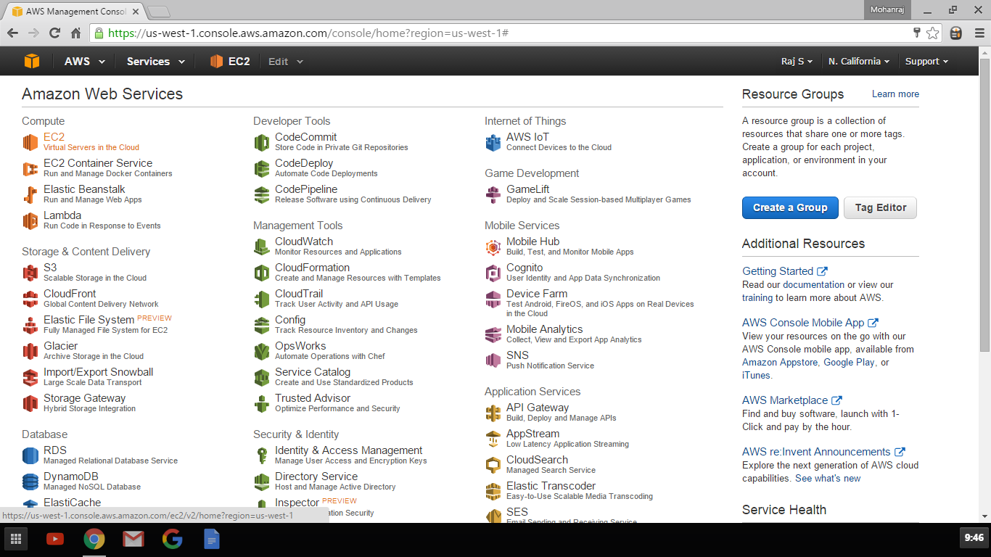

Click Launch Instance

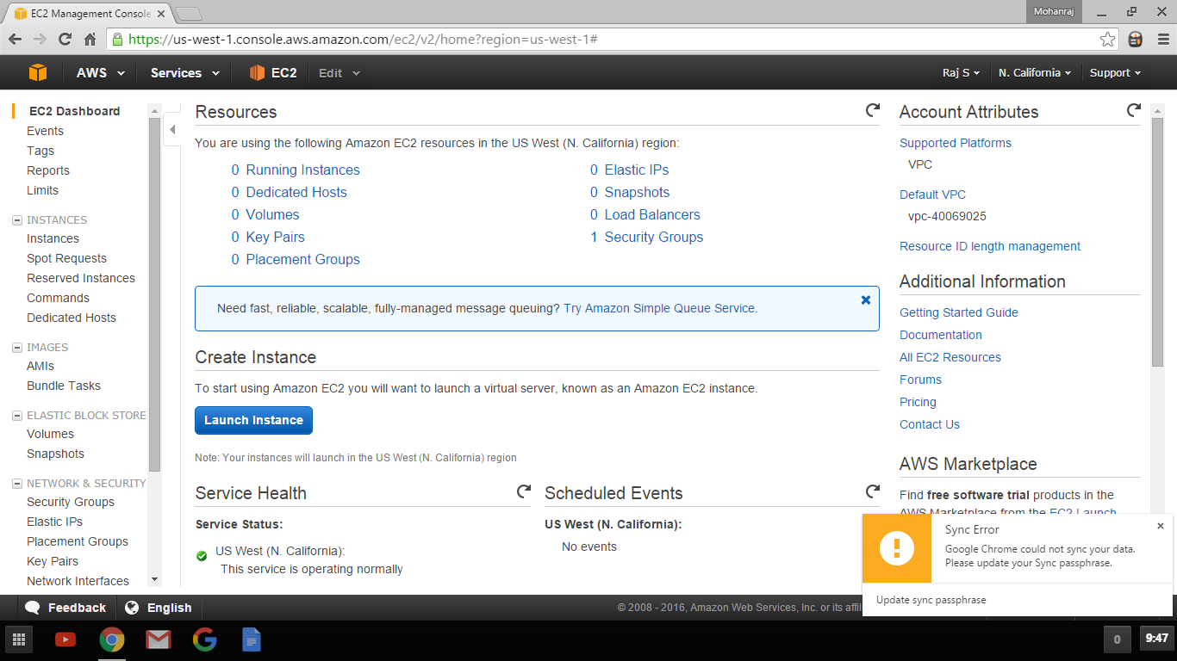

Select Amazon Linux AMI

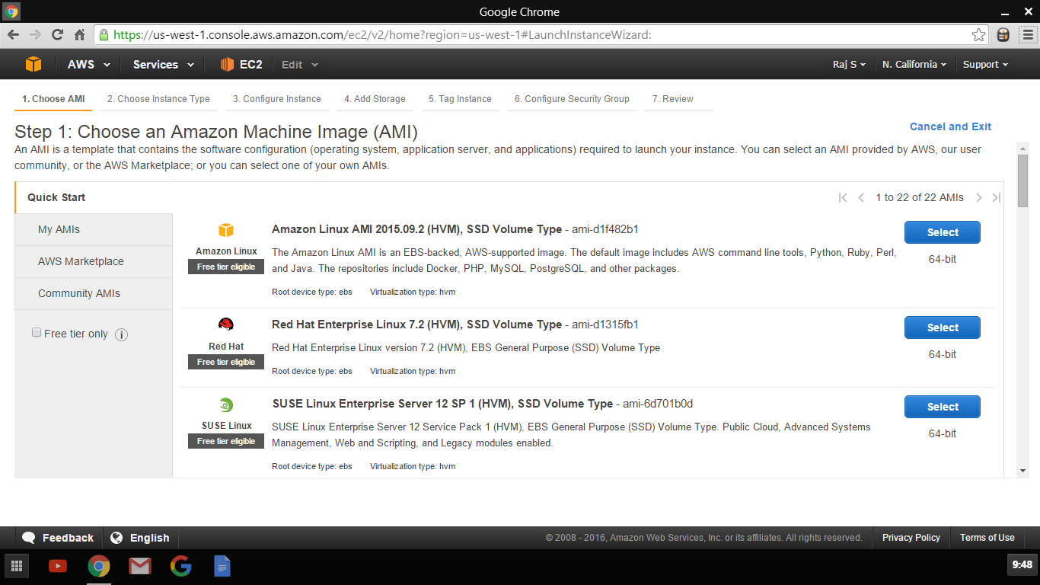

Choose T2.Micro and clock Review and Launch

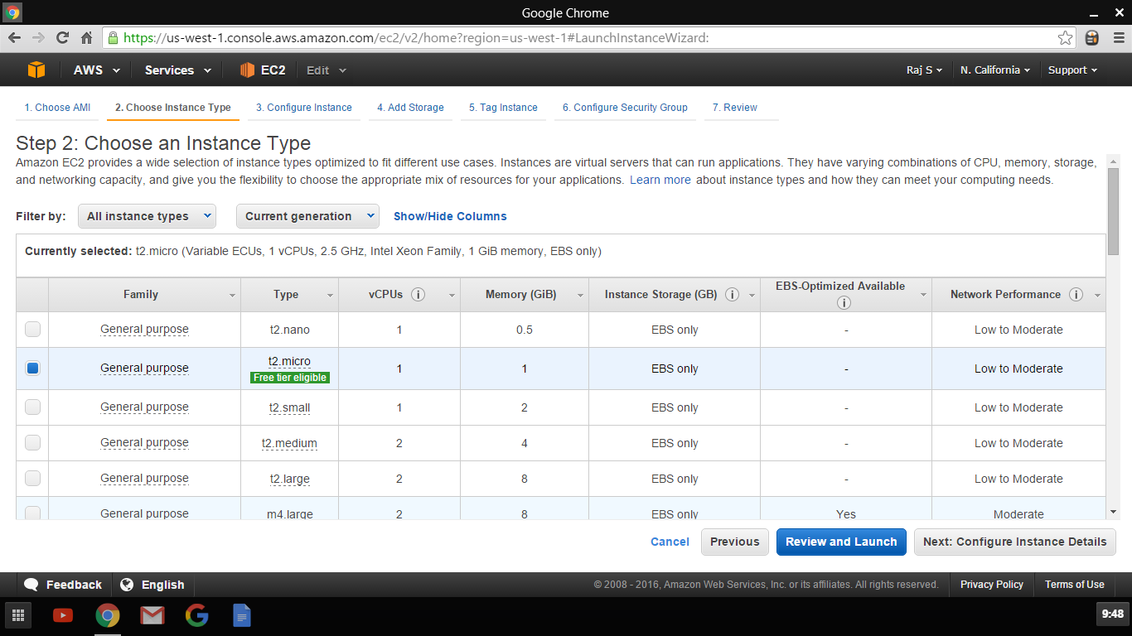

Click Launch in Review Screen

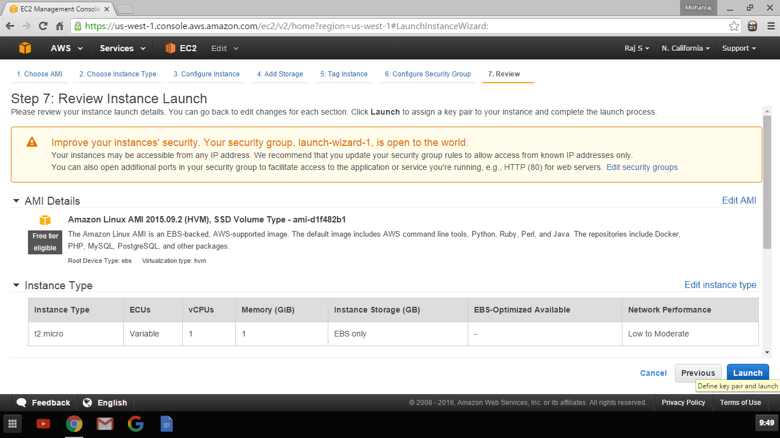

Choose Create New Key Pair and provide Name and Download Keys

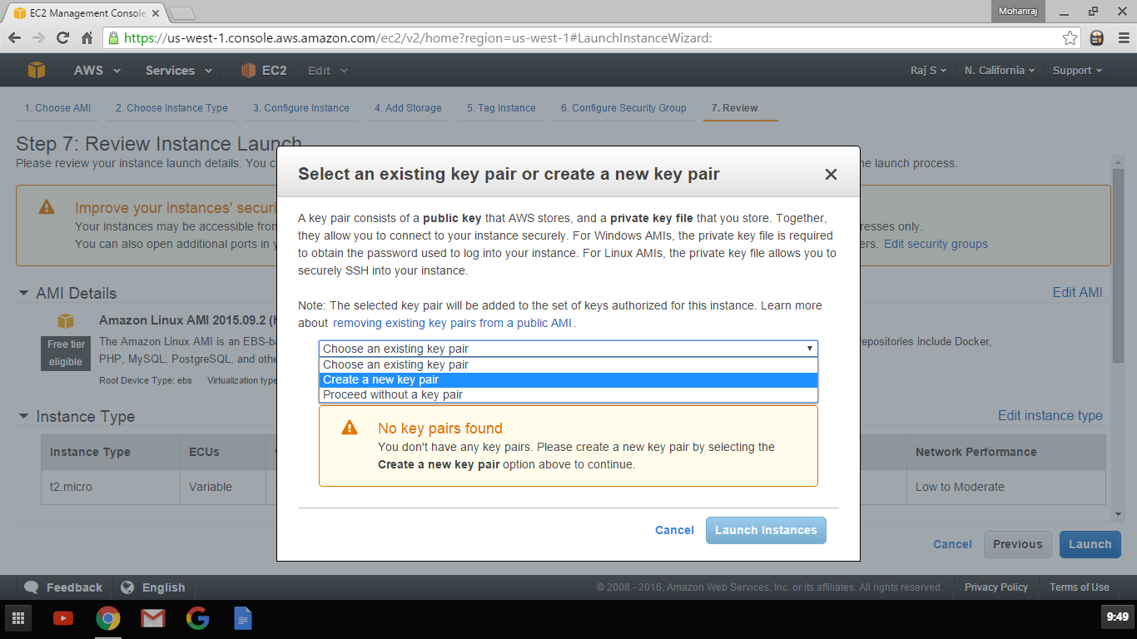

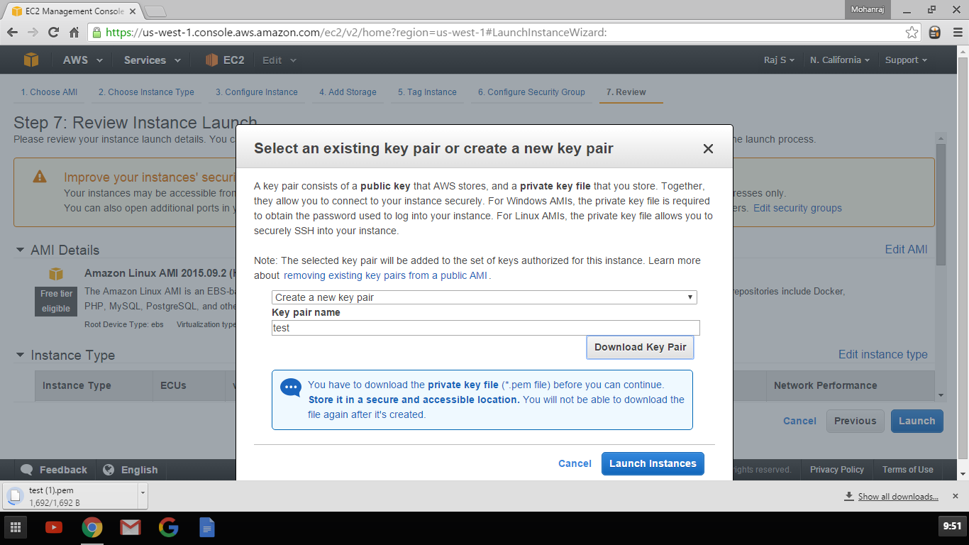

Click view instance Id i-xxxxxxx to take you EC2 Console

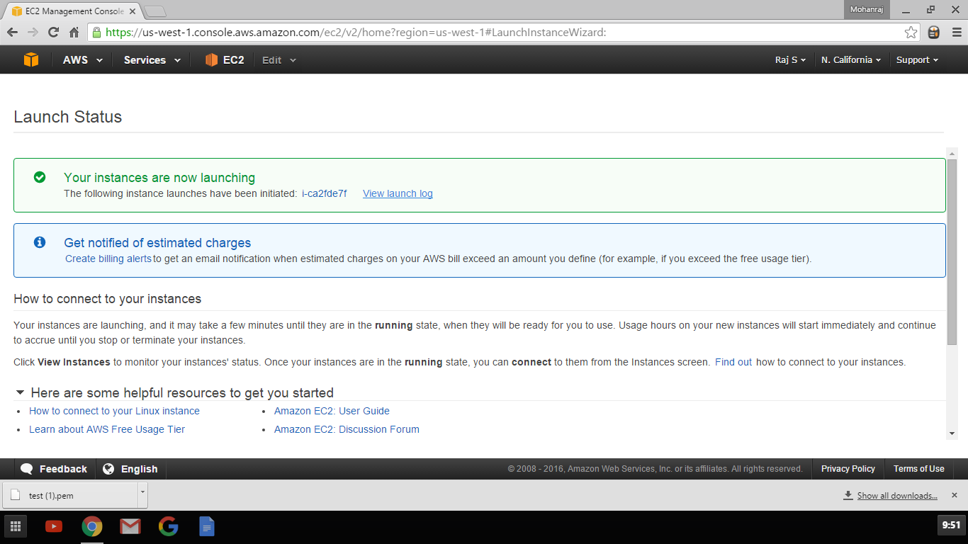

Click Connect tab to find the Options to connect

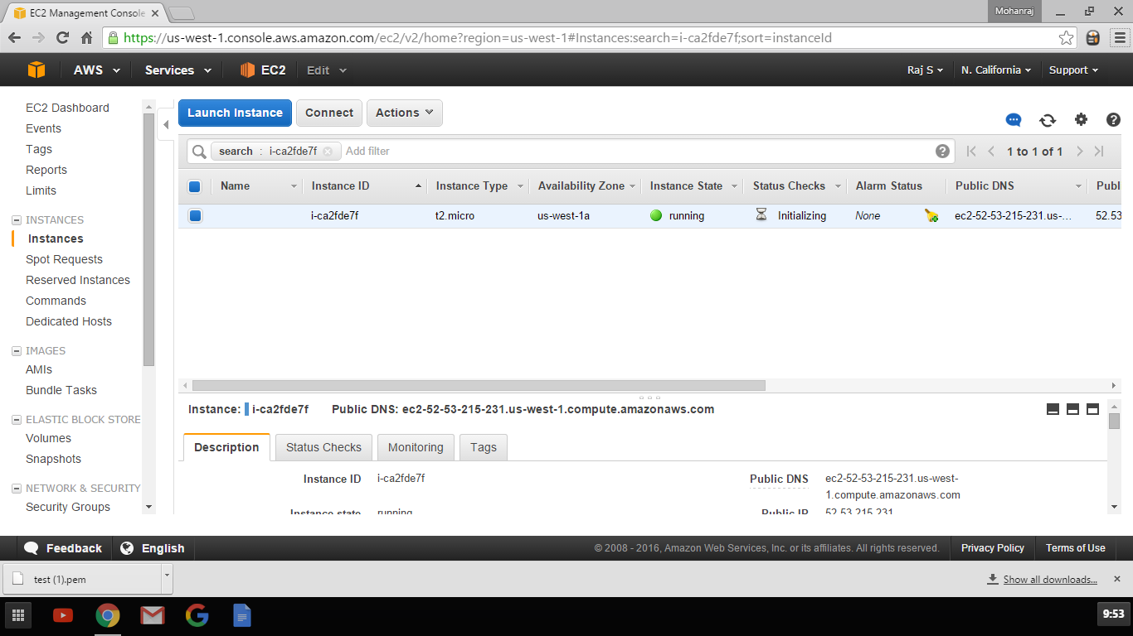

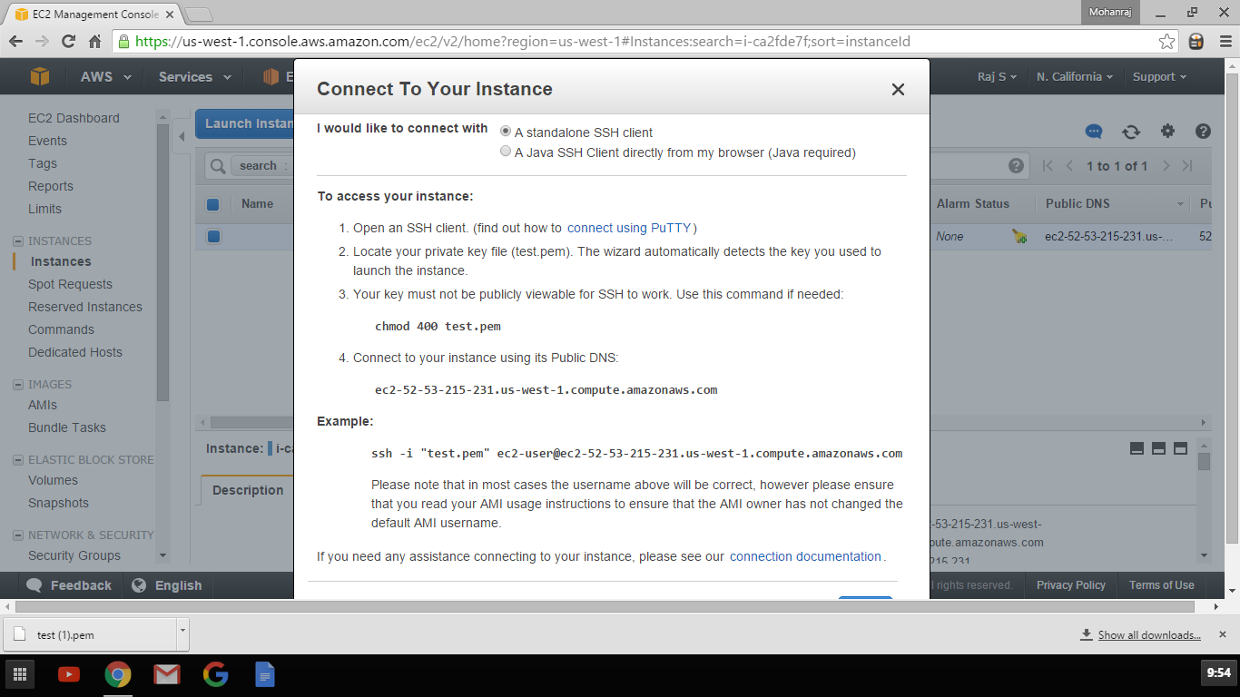

Connecting using Putty

Download Putty and PuttyGen from the below URL

<http://www.chiark.greenend.org.uk/~sgtatham/putty/download.html>

Open PuttyGen

Open Putty Key Generator

Machine generated alternative text:
Eile Key 
No key 
Conversions 
PuTTY Key Generator 
Help 
Save private key 
Save public key 
Generate a public/private key pair 
laad an existing private key file 
Save the generated key 
Parameters 
Type of key to generate 
o 
SSH-I (RSA) 
@SSH-2 RSA 
O SSH-2 OSA 
Number of bits In a generated key 

Click Load and lead the PEM File downloaded while creating the Instance

Select All Files to show the .pem files

Machine generated alternative text:
File 
Organize 
Key 
PuTTY Key Generator 
Conversions Help 
Load private key: 
Search Downloads 
ThisPC 
New folder 
Downloads 
test (I).pem 
test_kp.ppk 
test (I).pem 
test.pem 
The Palette Logo 
Questionnaire (I) 
Desktop 
Google Drive 
OneDrive 
Documents 
Pictures 
Homegroup 
This pc 
Desktop 
Documents 
Music 
File name: 
test.ppk 
The Palette Logo 
Questionnaire (2) 
test_kp.pem 
The Palette Logo 
Questionnaire 
(2)-2 (1) 
v 
All Files ff.') 

Use Save private key to Save it in PPK Format which Putty Understands

Machine generated alternative text:
PuTTY Key Generator 
File Key Conversions Help 
Public key for pasting into OpenSSH authorized_keys filæ 
AAAAB3NzaC1yc2EAAA.ADAQABAAABAQCh5KVgj5VQxGqHIZR 
LZpX4-11 BOwD02XPpSGx5LONu03si4uCE 
CtTPwBsgJPvTOTor5FJB5bgBVQcUFRlhYCfR4b% 
+8XDJBkC02PSUhJBVooUoUQ0AOPlqMhiFCNOLj3UUStZvAykTU6BFDE180SNW 
7dx50aooVOMEuEE 
PuTTYgen Notice 
Successfully imported foreign key 
(OpenSSH SSH-2 private key). 
imported -o pensshkey 
To use this key with PuTTY, you need to 
use the "Save private key" command to 
save it in PUTTY's own format. 
e key pair 
e key file 
Parameters 
Type of key to generate 
o 
SSH-I (RSA) 
@SSH-2 RSA 
O SSH-2 OSA 
Number of bits In a generated key 

Machine generated alternative text:
PuTTY Key Generator 
File Key Conversions Help 
Public key for pasting Into OpenSSH authorized_keys file 
ssl„-sa 
BOwD02XPpSGx5LONu03si4uCE 
CtTPwBsgJPvTOTor5FJB5bgBVQcUFRlhYCfR4b% 
+8XDJBkC02PSUhJBV00UoUQ0AOPIqMhiFCNOLj3UUStZvAykTU6BFDE180SNW 
7dx50aooVOMEuEE 
Key fingerprint 
2048 5cb9E4b2:36 33bd:16S2 7059 
e key pair 
rate key file 
PuTTYgen Warning 
Are you sure you want to save this key 
without a passphrase to protect it? 
O SSH-2 OSA 
key 
Parameters 
Type of key to generate 
o 
SSH-I (RSA) 
@SSH-2 RSA 
Number of bits In a generated key 

Machine generated alternative text:
File 
Organize 
Key 
PuTTY Key Generator 
Conversions Help 
Save private key as: 
This PC Desktop 
New folder 
Search Desktop 
TAMIL LATEST 
MP3 
Rasberry Pi 
test 
PuTTY Private Key Files C.ppk) 
Course contents 
Google Drive 
OneDrive 
Documents 
Pictures 
Homegroup 
This pc 
Desktop 
Documents 
Downloads 
File name: 
Save as type: 
Hide Folders 

Open Putty

Machine generated alternative text:
Cat egory 
Logging 
Terminal 
Keybo ard 
Window 
Behaviour 
Translation 
Selection 
Colours 
Telnet 
Rlogin 
+ SSH 
PuTTY Configuration 
Basic options for your Pu TTY session 
Specify the destination you want to connect to 
Host Name (or IP address) 
Connection type 
C) Raw C) Telnet C) Rlogin @SSH C) 
laad save or delete a stored session 
Saved Sessions 
Defautt Settings 
AWS 
yodemo 
y2/abOI 
yoservO I 
y2ytech com 
Close window on exit 
o 
Always C) Never 
Save 
• Only on clean exit 

Click SSH-> Auth -> Choose the private key saved

Machine generated alternative text:
Cat egory 
Window 
Behaviour 
Translation 
Colours 
Telnet 
Rlogin 
SSH 
Auth 
GSSAPI 
Tunnels 
PuTTY Configuration 
Options controlling SS H authentication 
Bypass authentication entirely (SS H-2 only) 
Display pre-authentication banner (SS H-2 only) 
ktempt authentication using Pageant 
kempt TIS or CryptoCard auth (SSH-I) 
ktempt 'keyboard*nteractive" auth (SSH-2) 
Authentication parameters 
Alow agent forwarding 
Alow attempted changes of usemame in SSH-2 
Private key file for authentication 

Machine generated alternative text:
Cat egory 
Window 
Behaviour 
Translation 
Colours 
Telnet 
Rlogin 
SSH 
Auth 
GSSAPI 
Tunnels 
PuTTY Configuration 
Options controlling SS H authentication 
Bypass authentication entirely (SS H-2 only) 
Display pre-authentication banner (SS H-2 only) 
kempt authentication using Pageant 
kempt TIS or CryptoCard auth (SSH-I) 
ktempt 'keyboard*nteractive" auth (SSH-2) 
Authentication parameters 
Alow agent forwarding 
Alow attempted changes of usemamein SSH-2 
Private key file for authentication 

Go to session and Put the DNS name show in Connect Tab of AWS console

Machine generated alternative text:
Cat egory 
Logging 
Terminal 
Keybo ard 
Window 
Behaviour 
Translation 
Colours 
Telnet 
Rlogin 
SSH 
PuTTY Configuration 
Basic options for your Pu TTY session 
Specify the destination you want to connect to 
Host Name (or IP address) 
Connection type 
C) Raw C) Telnet C) Rlogin @SSH C) 
laad save or delete a stored session 
Saved Sessions 
Defautt Settings 
AWS 
yodemo 
y2/abOI 
yoservO I 
y2ytech com 
Close window on exit 
o 
Always C) Never 
Save 
• Only on clean exit 

Enter ec2-user as User name

Machine generated alternative text:
ec2-52-53-215-231.us-west- l.compute.amazonaws.com - PuTTY 
login as: 

It connects to the VM Using Private Key instead of Passwords.

Machine generated alternative text:
ec2-user@ip-172-31-5-211•- 
login as: ec2—usez 
Authenticating with public key 
Amazon Linux AMI 
https : / laws . amazon . . 
No packages needed for security; 3 packages available 
Run "suda yum update" to apply all updates. 
lec2-userUp-172-31-s-211 -IS Cl 

Machine generated alternative text:
ec2-user@ip-172-31-5-211:- 
as: ec2—usez 
Authenticating with public key 
Amazon Linux AMI 
https : / laws . amazon . . 
No packages needed for security; 3 packages available 
0 02 
Run "suda yum update" to apply all updates. 
—IS uptime 
up 17 min, I user, 
load average : 
lec2-userUp-172-31-s-211 -IS Cl 
0.00, 
0.01, 

Terminate the VM

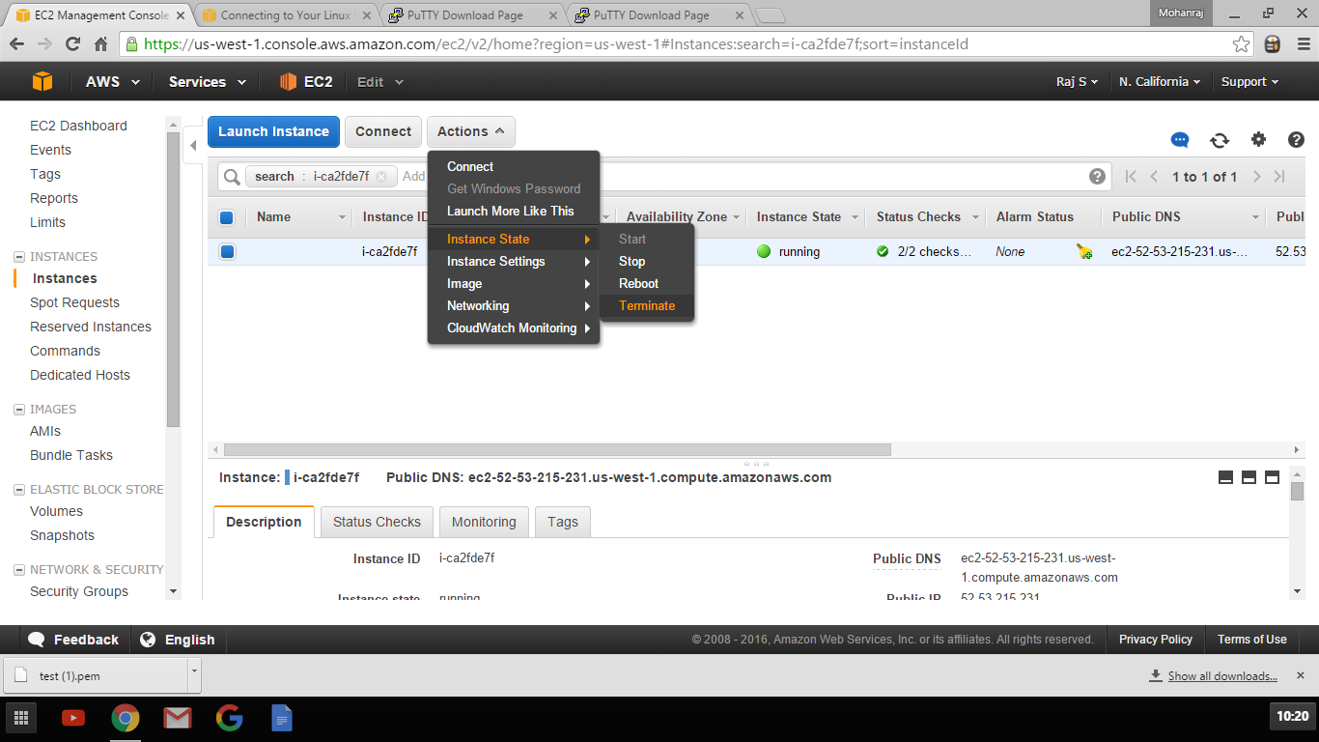

**Access Windows VM**

Launch Instances and Choose Windows 2012 R2

Machine generated alternative text:
EC2 Management Consol+ X Connecting to Your Linux X PuTTY Download Page X i" 
C https://us-west-l.console.aws.amazon.com/ec2/v2/home?region 
PuTTY Download Page X 
-us-west-1#LaunchlnstanceWizard: 
7. Review 
Rajsv 
Mohanraj 
N. California 
f-?IS 
Support 
AWS v 
Services 
1. Choose AMI 
2. Choose Instance Type 
EC2 
Edit 
3. Configure Instance 
4. Add Storage 
6 Configure Security Group 
5. Tag Instance 
Cancel and Exit 
64-bit 
Select 
64-bit 
Select 
64-bit 
Hide 
Step 1: Choose an Amazon Machine Image (AMI) 
Q Feedback 
test (I).pem 
SUSE Linux 
Free tier enble 
Ubuntu 
Free tier enble 
Windows 
Free tier enble 
SLISE Linux Enterprise Server 12 Service Pack 1 (HVM), 
EBS General Purpose (SSD) Volume Type. Public Cloud, Advanced Systems 
Management, Web and Scripting, and Legacy modules enabled. 
Root device type: ebs Virtualization type: hvm 
Ubuntu Server 14.04 LTS (HVM), SSD Volume Type - ami-06116566 
Llbuntu Server 14.04 L TS (HVM), EBS General Purpose (SSD) Volume Type. Support available from Canonical 
(http://wwv.ubuntu.com/cloud/services). 
Root device type: ebs Virtualization type: hvm 
Microsoft Windows Server 2012 R2 Base - ami-95fd8bf5 
Microsoft Windows 2012 R2 Standard edition with 64-bit architecture. (English) 
Root device type: ebs Virtualiz ation type: hvm 
Are you launching a database instance? Try Amazon ROS. 
e English 
Amazon Relational Database Service (ROS) makes it easy to set up, operate, and scale a relational database ot your choice (MySQL, 
@200B - 2016, Amazon Web Services, Inc or its affiliates All rights reservecL 
Privacy Policy Terms of Use 
Show all downloads... X 
10:21 

Choose t2.micro instance and click review and launch

Machine generated alternative text:
EC2 Management Consol+ X Connecting to Your Linux X PuTTY Download Page X i" 
C https://us-west-l.console.aws.amazon.com/ec2/v2/home?region 
PuTTY Download Page X 
-us-west-1#LaunchlnstanceWizard: 
Rajsv 
Mohanraj 
N. California 
f-?IS 
Support 
AWS v 
Services 
1. Choose AMI 
2. Choose Instance Type 
EC2 
Edit 
3. Configure Instance 
4. Add Storage 
6. Configure Security Group 
7. Review 
5. Tag Instance 
Step 2: Choose an Instance Type 
Amazon EC2 provides a wide selection ot instance types optimized to tit ditterent use cases. Instances are virtual servers that can run applications. They have varying combinations ot CPL), memory, storage, 
and networking capacity, and give you the flexibility to choose the appropriate mix ot resources tor your applications. Learn more about instance types and how they can meet your computing needs. 
Filter by: All instance types 
Current generation 
Show/Hide Columns 
EBS-Optimized Available 
0) 
Review and Launch 
Network Performance 
Low to Moderate 
Low to Moderate 
Low to Moderate 
Low to Moderate 
Next: Configure Instance Details 
Currently selected: t2_micro (Variable EClJs, 1 vCPlJs, 25 GHz, Intel Xeon Family, 1 Gia memory, ESS only) 
Family 
General 
General purpose 
General 
General 
Type 
t2_nano 
t2_micro 
Free tier eligible 
t2_small 
t2_medium 
vCPUs 0) 
2 
Memory (GiB) 
0.5 
2 
4 
Instance Storage (GB) 
Eas ony 
Eas ony 
Eas ony 
Eas ony 
e English 
Cancel 
Previous 
Privacy Policy Terms of Use 
Show all downloads... X 
10:22 
Q Feedback 
test (I).pem 
@200B - 2016, Amazon Web Services, Inc or its affiliates All rights reservecL 

Click Launch on review page

Machine generated alternative text:
EC2 Management Consol+ X Connecting to Your Linux X PuTTY Download Page X i" 
C https://us-west-l.console.aws.amazon.com/ec2/v2/home?region 
PuTTY Download Page X 
-us-west-1#LaunchlnstanceWizard: 
Rajsv 
Mohanraj 
N. California 
f-?IS 
Support 
Edit AMI 
AWS v 
Services 
1. Choose AMI 
2. Choose Instance Type 
EC2 
Edit 
3. Configure Instance 
4. Add Storage 
6. Configure Security Group 
5. Tag Instance 
7. Review 
EBS-Optimized Available 
Step 7: Review Instance Launch 
Details 
Microsoft Windows Server 2012 R2 Base - ami-95fd8bf5 
Free ber 
eligible 
Microsoft Windows 2012 R2 Standard edition with 64-bit architecture. (English) 
Root Device Type: ebs Virtualization ty pe: hvm 
Memory (GiB) 
ECUS 
Variable 
VCPUS 
Instance Type 
Instance Type 
t2_micro 
Security Groups 
Security group name 
Edit instance type 
Network Performance 
Low to Moderate 
Edit security groups 
Instance Storage (GB) 
Eas ony 
Cancel 
Previous 
launch-wizard-2 
Q Feedback 
test (I).pem 
Launch 
Define key pair and launch 
Privacy Policy Terms of Use 
Show all downloads... X 
10:22 
e English 
@200B - 2016, Amazon Web Services, Inc or its affiliates All rights reservecL 

Download Key Pair

Machine generated alternative text:
EC2 Management Consol+ X Connecting to Your Linux X PuTTY Download Page X i" 
https://us-west-1.console.aws.amazon.com/ec2/v2/home?region 
PuTTY Download Page X 
-us-west-1#LaunchlnstanceWizard: 
7. Review 
Raj s v 
Mohanraj 
N. California 
f-?IS 
Support 
Edit AMI 
Choose AMI 
Services 
2 Choose Instance Type 
Configure Security Group 
Ill) EC2 Edit v 
Configure Instance 
Add Storage 
Tag Instance 
Step 7: Review Instance Lau 
AMI Details 
x 
Select an existing key pair or create a new key pair 
A key pair consists ot a public key that AWS stores, and a private key tile that you store. Together, 
they allow you to connect to your instance securely. For Windows AMIs, the private key tile is required 
to obtain the password used to log into your instance. For Linux AM's, the private key tile allows you to 
securely SSH into your instance. 
Note: The selected key pair will be added to the set ot keys authorized tor this instance. Learn more 
about removing existing key pairs trom a public AMI _ 
Create a new key pair 
Key pair name 
tesnwin 
Download Key Pair 
You have to download the private key tile tile) betore you can continue. 
Store it in a secure and accessible location. You will not be able to download the 
tile again atter it's created. 
Free tier 
eligible 
Microsoft Windows Server 
Microsoft Windows 2012 R2 Stand 
Root Device Ty pe: ebs Virtualization t/ 
ECUS 
Variable 
launch-wiza 
Instance Type 
Instance Type 
t2_micro 
Security Groups 
Security group name 
Edit instance type 
Network Performance 
Low to Moderate 
Edit security groups 
Cancel 
Launch Instances 
Cancel 
Previous 
Q Feedback 
testwin.pem 
Launch 
e English 
• test (I).pem 
Privacy Policy Terms of Use 
Show all downloads... X 
10:22 

Once Instance is in ready state click Connect

Machine generated alternative text:
EC2 Management Consol+ X Connecting to Your Linux X PuTTY Download Page X i" 
PuTTY Download Page X 
C https://us-west-1.console.aws.amazon.com/ec2/v2/home?region-us-west-1#lnstances:searchzi-4013e2f5;sortzinstanceld 
ID 
x 
arm 
Raj s v 
o 
Status 
Mohanraj 
N. California 
f-?IS 
Support 
EC2 Dashboard 
Events 
Tags 
Reports 
Limits 
IH INSTANCES 
I Instances 
Spot Requests 
Reserved Instances 
Commands 
Dedicated Hosts 
IMAGES 
AMIS 
Bundle Tasks 
Services 
Ill) EC2 Edit v 
Actions v 
Connect 
Launch Instance 
search 
Name 
Ito 1 ot 1 
Public DNS 
ec2-54-193-44-143.us-... 
Connect To Your Instance 
You can connect to your Windows instance using a remote desktop client ot your choice, and by 
downloading and running the RDP shortcut tile below: 
Download Remote Desktop File 
When prompted, connect to your instance using the tollowing details: 
public DNS ec2-54-193-44-143_us-west-1 _compute_amazonaws_com 
User name Administrator 
Password Get Password 
Publ 
54.19 
It you've joined your instance to a directory, you can use your directory credentials to connect to your 
instance. 
It you need any assistance connecting to your instance, please see our connection documentation 
Close 
Instance: I i 
ELASTIC BLOCK STORE 
Volumes 
Description 
Snapshots 
IH NETWORK SECURITY 
Security Groups 
Q Feedback English 
•e 2ÜÜ8- 
93-44-143. us-west- 
pute.amazonaws.com 
Privacy Policy Terms of Use 
Show all downloads... X 
10:24 
Amazon Services Inc or its affiliates All rights reservecL 
testwin.pem 
• test (I).pem 

Click Get Password, Upload key file and click Decrypt password to get Administrator password

Save the password

Machine generated alternative text:
EC2 Management Consol+ X Connecting to Your Linux X PuTTY Download Page X i" 
PuTTY Download Page X 
C https://us-west-1.console.aws.amazon.com/ec2/v2/home?region-us-west-1#lnstances:searchzi-4013e2f5;sortzinstanceld 
x 
Raj s v 
o 
Status 
Mohanraj 
N. California 
f-?IS 
Support 
EC2 Dashboard 
Events 
Tags 
Reports 
Limits 
IH INSTANCES 
I Instances 
Spot Requests 
Reserved Instances 
Commands 
Dedicated Hosts 
IMAGES 
AMIS 
Bundle Tasks 
ELASTIC BLOCK STORE 
Volumes 
Snapshots 
IH NETWORK SECURITY 
Security Groups 
Q Feedback English 
Services 
Ill) EC2 Edit v 
Actions v 
Connect 
Launch Instance 
search 
Name 
Instance: I i 
Description 
Ito 1 ot 1 
Public DNS 
ec2-54-193-44-143.us-... 
Connect To Your Instance Get Password 
The tollowing Key Pair was associated with this instance when it was created. 
Key Name testwin_pem 
In order to retrieve your password you will need to specify the path ot this Key Pair on your local 
machine: 
Key Pair Path Choose File No tile chosen 
Or you can copy and paste the contents ot the Key Pair below: 
Decrypt Password 
arm 
Publ 
54.19 
Instance ID 
i-4013e2f5 
•e 2ÜÜ8- 
Back 
Close 
-54-193-44-143.us-west- 
1.compute.amazonaws.com 
Public DNS 
Amazon Services Inc or its affiliates All rights reservecL 
Privacy Policy Terms of Use 
Show all downloads... X 
10:28 
testwin.pem 
• test (I).pem 

Machine generated alternative text:
EC2 Management Consol+ X Connecting to Your Linux X PuTTY Download Page X i" 
PuTTY Download Page X 
C https://us-west-1.console.aws.amazon.com/ec2/v2/home?region-us-west-1#lnstances:searchzi-4013e2f5;sortzinstanceld 
x 
Raj s v 
o 
Status 
Mohanraj 
N. California 
f-?IS 
Support 
EC2 Dashboard 
Events 
Tags 
Reports 
Limits 
IH INSTANCES 
I Instances 
Spot Requests 
Reserved Instances 
Commands 
Dedicated Hosts 
IMAGES 
AMIS 
Bundle Tasks 
ELASTIC BLOCK STORE 
Volumes 
Snapshots 
IH NETWORK SECURITY 
Security Groups 
Q Feedback English 
Services 
Ill) EC2 Edit v 
Actions v 
Connect 
Launch Instance 
search 
Name 
Instance: I i 
Description 
Ito 1 ot 1 
Public DNS 
ec2-54-193-44-143.us-.. 
Connect To Your Instance 
You can connect to your Windows instance using a remote desktop client ot your choice, and by 
downloading and running the RDP shortcut tile below: 
Download Remote Desktop File 
When prompted, connect to your instance using the tollowing details: 
public DNS ec2-54-193-44-143_us-west-1 _compute_amazonaws_com 
User name Administrator 
Password hXT2aWm_seN 
arm 
Publ 
54.19 
It you've joined your instance to a directory, you can use your directory credentials to connect to your 
instance. 
It you need any assistance connecting to your instance, please see our connection documentation 
Instance ID 
i-4013e2f5 
•e 2ÜÜ8- 
Close 
Public DNS 
ec2-54-193-44-143.us-west- 
1.compute.amazonaws.com 
Privacy Policy Terms of Use 
Show all downloads... X 
10:30 
Amazon Services Inc or its affiliates All rights reservecL 
testwin.pem 
• test (I).pem 

Click Connect again and click download Remote desktop file

Machine generated alternative text:
EC2 Management Consol+ X Connecting to Your Linux X PuTTY Download Page X i" 
PuTTY Download Page X 
C https://us-west-1.console.aws.amazon.com/ec2/v2/home?region-us-west-1#lnstances:searchzi-4013e2f5;sortzinstanceld 
x 
arm 
Raj s v 
o 
Status 
Mohanraj 
N. California 
f-?IS 
Support 
EC2 Dashboard 
Events 
Tags 
Reports 
Limits 
IH INSTANCES 
I Instances 
Spot Requests 
Reserved Instances 
Commands 
Dedicated Hosts 
IMAGES 
AMIS 
Bundle Tasks 
ELASTIC BLOCK STORE 
Volumes 
Snapshots 
IH NETWORK SECURITY 
Security Groups 
Q Feedback English 
Services 
Ill) EC2 Edit v 
Actions v 
Connect 
Launch Instance 
search 
Name 
Instance: I i 
Description 
Publ 
54.19 
Ito 1 ot 1 
Public DNS 
ec2-54-193-44-143.us-... 
Connect To Your Instance 
You can connect to your Windows instance using a remote desktop client ot your choice, and by 
downloading and running the RDP shortcut tile below: 
Download Remote Desktop File 
When prompted, connect to your instance using the tollowing details: 
public DNS ec2-54-193-44-143_us-west-1 _compute_amazonaws_com 
User name Administrator 
Password Get Password 
It you've joined your instance to a directory, you can use your directory credentials to connect to your 
instance. 
It you need any assistance connecting to your instance, please see our connection documentation 
Close 
•e 2ÜÜ8- 
193-44-143. us-west- 
1.compute.amazonaws.com 
Amazon Services Inc or its affiliates All rights reservecL 
Privacy Policy Terms of Use 
Show all downloads... X 
10:31 
testwin.pem 
• test (I).pem 

Click Connect

Machine generated alternative text:
Remote Desktop Connection 
TYE tNs be you to 
Miyway ? 
This remote connection could harm your local or remote computer Do not connect unless you know 
where this connection came from or have used t 
Remote computer: 
Remote Desktop Connection 
ec2-54-19344-143 uswest-l compute amazonawsc 
Don t ask me again for connections to this computer 
Show Details 

Type Admin Password

Machine generated alternative text:
Windows Security 
Enter your credentials 
These credentials will be used to connect to 
ec2- 54- I "-44-143.us-west- I .compute.amazonaws.com. 
Administrator 
Use another account 
Remember my credentials 

You are now connected to Windows Desktop

Machine generated alternative text:
Recycle Bin 
Feedback 
Micros... 
Windows Server 2012 R2 
AM 
2/26/2016 

Terminate the VM

